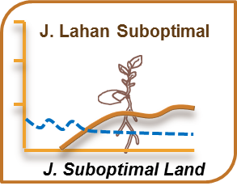
JURNAL LAHAN SUBOPTIMAL
Journal of Suboptimal Lands
PUSAT UNGGULAN RISET
PENGEMBANGAN LAHAN SUBOPTIMAL (PUR-PLSO)
UNIVERSITAS SRIWIJAYA
Jl. Padang Selasa No.524, Bukit Besar, Palembang 30139
Telpon/Faksimil: +62711352879
E-mail: jlsuboptimal@unsri.ac.id http://www.jlsuboptimal.unsri.ac.id

Copyright form
Manuscript ID of paper (Official use only): ..........................
Title of paper: Size of Tiller and Water Table Effects in Celery Growth on Floating Cultivation System
Name(s) of Authors: Karla Kasihta Jaya, Benyamin Lakitan
Name and address of Principal Author: Karla Kasihta Jaya
E-mail: kkasihtajaya@gmail.com Phone : 081267987967
- The author(s) reserve(s) all proprietary rights such as patent rights and the right to use all or part of the article in future works of their own such as lectures, press releases, and reviews of textbooks. In the case of republication of the whole, part, or parts thereof, in periodicals or reprint publications by a third party, written permission must be obtained from the Editor-in-Chief Jurnal Lahan Suboptimal: Journal of Suboptimal Lands.
- I hereby declare that the material being presented by me in this paper is our original work, and does not contain or include material taken from other copyrighted sources. Wherever such material has been included, it has been clearly indented or/and identified by quotation marks and due and proper acknowledgements given by citing the source at appropriate places.
- The paper, the final version of which I enclose, is not substantially the same as any that I/we have already published elsewhere.
- I/we have not sent the paper or any paper substantially the same as the enclosed one, for publication anywhere else.
- Furthermore, the author may only post his/her version provided acknowledgement is given to the original source of publication and a link is inserted to the published article on Jurnal Lahan Suboptimal: Journal of Suboptimal Lands. website.
- All the authors of this article agree for the publication of this article.
- The submitted/enclosed camera-ready paper is thoroughly proof read by me and in conformity with the instructions for authors communicated to me.

Author's signature(s): Karla Kasihta Jaya Date: 10 Maret 2020
…………………………………… Date: ..........................................…
…………………………………… Date: ..........................................…

